GCK Policy
“Complaints”

Objectives
For GCK to have comprehensive procedures in place for all complaints relating to the centre and that this is available to all related parties to access.

Procedures & Strategies
The Complaints Policy includes two procedures. These are:
- Complaints Procedures
- Licence Complaints

- Complaints Procedures
Purpose:
To ensure that there is a robust procedure for staff and parents for complaints to be made and managed.

Staff Complaints Procedure:
- In the case of a complaint against a member of staff, parents/caregivers should, in the first instance, approach the Head Teacher. The complaint should be discussed and recorded in writing. The Head Teacher should undertake to deal with the matter and respond to the complainant within seven (7) working days. The action taken should also be recorded.
- If the matter is not able to be resolved to the complainant’s satisfaction, they should then record their complaint in writing and deliver it to the Staff Liaison contact or Board Chairman, on the Trust Board. Once again the complaint should be recorded in a complaints register, and a written response sent to the complainant within seven (7) working days. The action taken and the result must also be recorded.
- In the event that the problem has still not been satisfactorily resolved, the complainant may wish to approach the Glendowie Christian Kindergarten Management Board, or, in extreme cases, the Ministry of Education.
- Complaints about breaches of licence conditions should be dealt with as outlined below.

Other Complaints Procedure:
- For any other complaints please discuss with the Centre Manager or contact the Chairman or Secretary of the Glendowie Christian Kindergarten Management Board

- Linked to Licensing Criteria GMA1
- Regulation 47

- Licence Complaints Procedure
Purpose:
The Licence granted to the GCK by the Ministry of Education will be prominently displayed at all times in the Centre. It specifies our permitted operating hours, maximum number of children, and their ages, and the minimum number of staff required. It is an important legal document. The Service Provider Contact person (SPCP) is a representative of the Glendowie Christian Kindergarten Management Board, which administers GCK.

Procedure:
- Parents who believe GCK has breached the terms of its licence should complain in writing in the first instance to the SPCP, as named on the licence.
- This complaint should be recorded by the SPCP, as should the actions taken to address it.
- The SPCP should respond to the complaint in writing within seven days outlining action taken.
- Parents who believe that grounds for complaint still exist, and who feel unable to have the problem resolved by the SPCP, should address their complaint in writing to the Ministry of Education, Auckland Regional Office, Private Bag 92644, Symonds Street Auckland 1150.

Parents are entitled to view a copy of the Education (Early Childhood Centres) Regulations (2008), which govern all aspects of our operations, and/or the most recent ERO report which are displayed on the notice board.

Regulation 47

Licensing criteria GMA 1
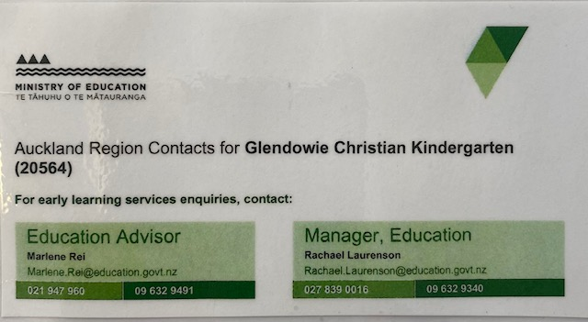

Glendowie Christian Kindergarten Complaints Register
Date | Person making Complaint | Description of complaint | Who took the complaint  Name  &  position | Response to the complainant  (within 7 working days) | Action taken | Results | Follow up required

