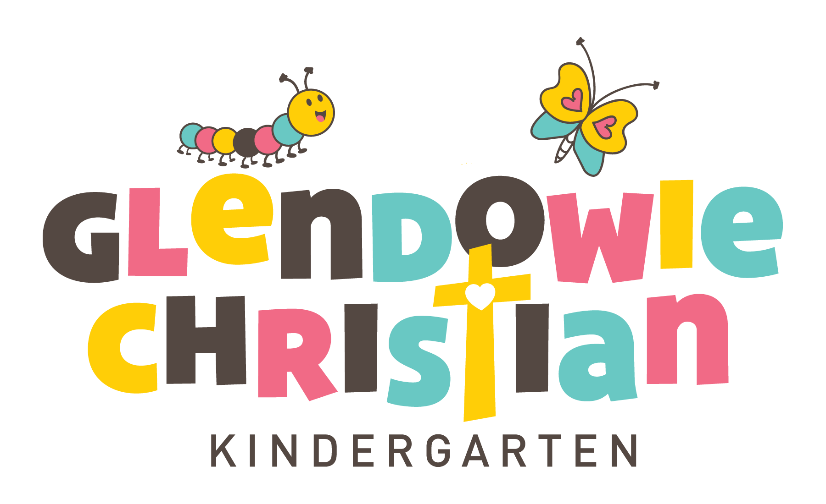GCK Philosophy Statement

Each child (Tamariki) entrusted into our care is a unique individual created by God. We treat each child and their family with love (aroha) and respect as they grow and develop within our wider “GCK Family”.

The GCK learning environment honours the unique bicultural heritage of New Zealand. GCK respects and acknowledges Te Tiriti o Waitangi. GCK celebrates the multi-cultural heritage of all our kindergarten families.

In every part of our day, directly and indirectly, our Christian beliefs are modelled and incorporated. We believe that children can develop their total potential when education and care is offered within this loving environment of Christian character and values.

GCK encourages children to develop fully as unique individuals and as valued members of the community. At GCK, we value ‘Te Whariki,’ our early childhood curriculum, and we incorporate this throughout the GCK environment. Our philosophy of the importance of children learning through play is recognised and nurtured. The program facilitates children’s curiosity, active exploration, self-paced and self-directed learning.

Our physical environment and the resources provided enable children to explore and develop physically, cognitively, emotionally, socially and spiritually, as they are supported in an environment of freedom, dignity, respect and safety. The importance of conservation, sustainability and a caring attitude are modelled and our children are encouraged to provide guardianship, enjoy and respect the beauty of God’s creation.

We believe that Early Childhood Education is an important collaborative partnership between Tamariki, whanau, hapu and Glendowie Christian Kindergarten. We endeavour to promote this partnership through all aspects of the children’s experiences at GCK as they first transition into kindergarten and later onto school and life.
(Version: Dec 2023)

